Installation instructions python tool

In the zip file you can find the following files:

* Main.py
  + This is the python script.
* Chromedriver.exe
  + The executable that will take control over your chrome browser.

**Required installations**

1: Chrome web browser

* Please check the version. Open the settings of the chrome browser.
* 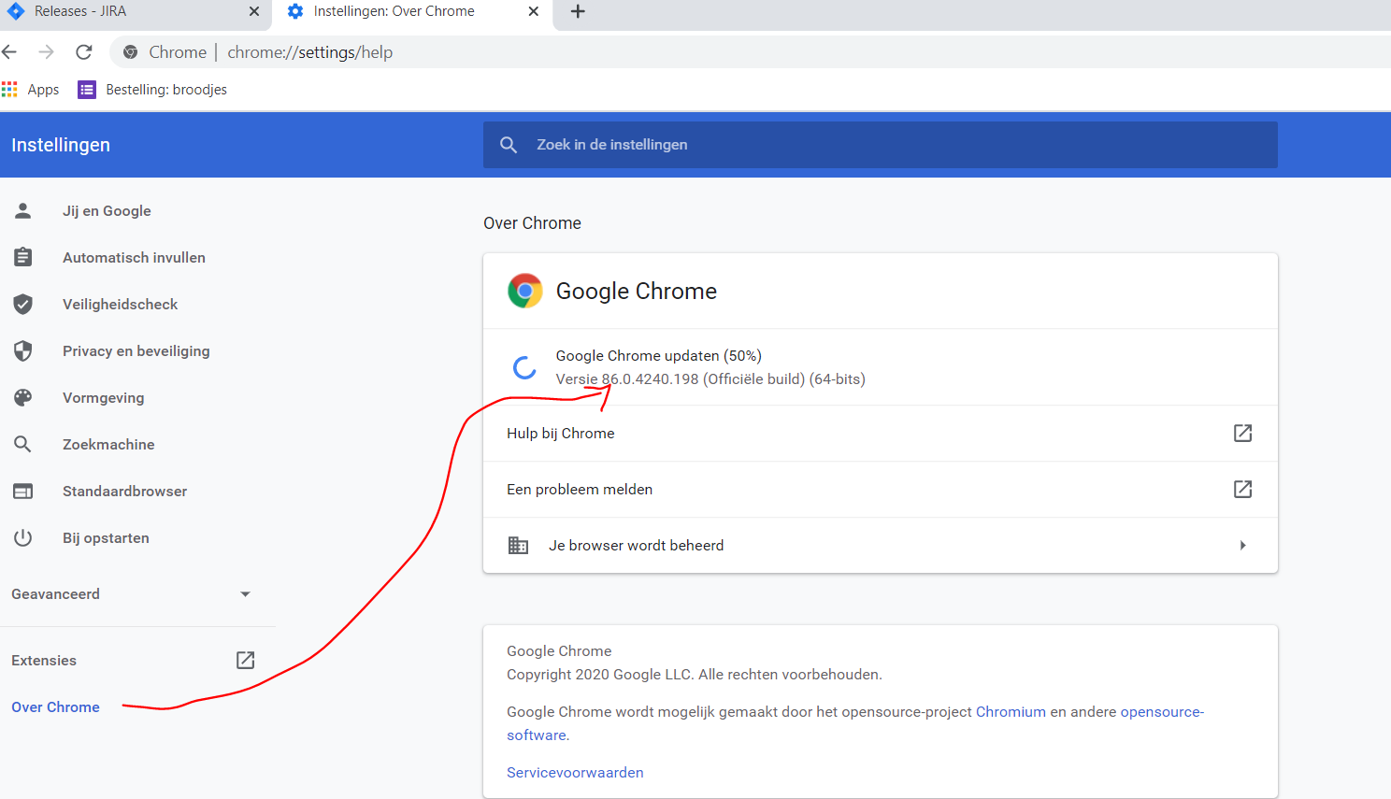
* In the example above, the version is 86.x.
  + The chromedriver that is needs to be compatible with the version of your chrome browser. You can find the lastest versions of the chromedriver [here](https://sites.google.com/a/chromium.org/chromedriver/downloads).
  + Download the chromedriver that matches your chrome browser version.
  + Place this .exe file in the same folder as the main.py script.
  + 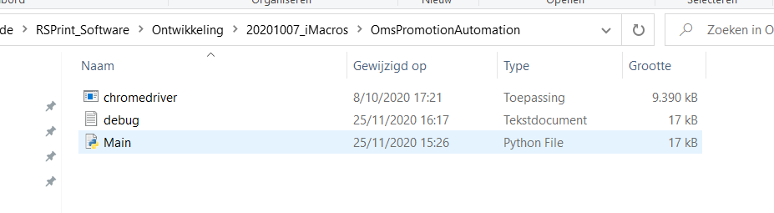
  + Chrome updates regularly. This is also the main reason the script will not initiate, as chrome version and chromedriver versions do not match. This is the first item to check if the tool fails to start.

2: Python

* Download the latest version compatible with your operating system ([link to site](https://www.python.org/downloads/)).
* Install it and add the executable to the path (you might need administrator rights for your computer).
* When opening a command prompt, you should be able to call the python executable and interact with it, like below. You can exit python by inserting ‘exit()’.
  + 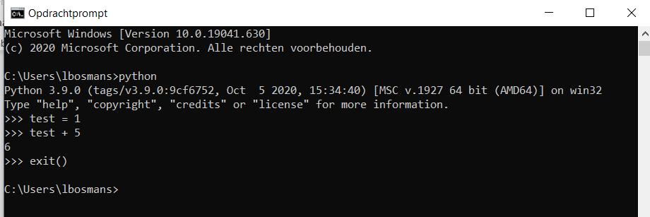
* Check if ‘pip’ works in a cmd (in a new prompt, not in python).
  + 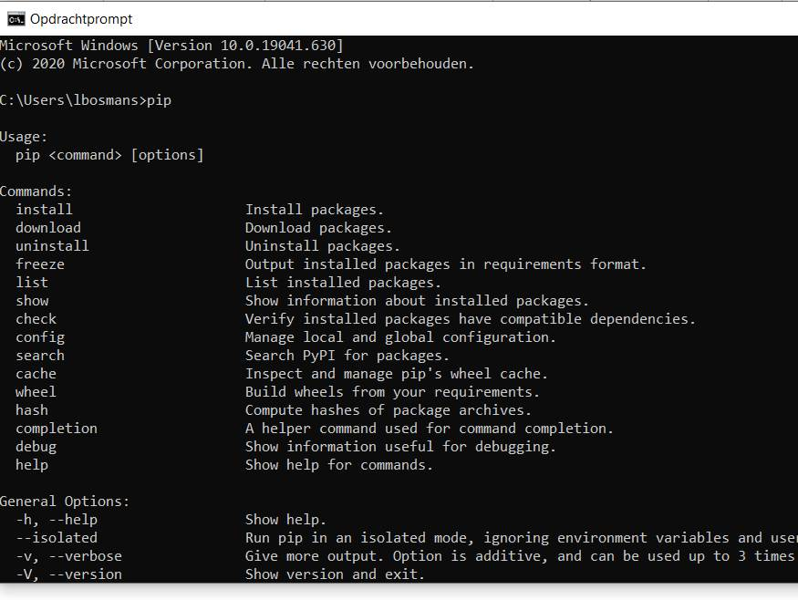
  + If yes, great.
  + If no, please follow [these instructions](https://phoenixnap.com/kb/install-pip-windows) if you use Windows. If you have another operating system (which I hope you don’t have), you’ll have to google it.
* Install python packages
  + Run the following three command in a cmd prompt, one by one
    - pip install update
    - pip install selenium
    - pip install chromedriver
  + Example
  + 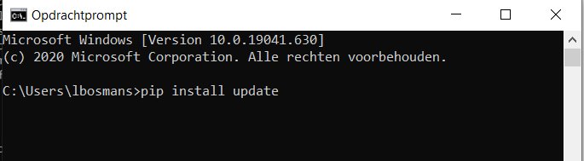

3: Optional: Visual Studio Code ([link to site](https://code.visualstudio.com/))

* This is a script editor.
* It is not required, but strongly advised. I have the feeling it works more stable than just running the script directly (although it technically shouldn’t matter).

**Use of the script using Visual Studio Code**

Using visual studio code:

* Open the main.py file in Visual Studio Code.
* If the editor suggests to install something (right bottom pop up), please do is. These are normally packages you need to run the script.
* Click ‘Run’ in the main menu.
* Click ‘Start debugging’. The tool will start.
* If a pop-up appears, click ‘Python file – debug python file’. This is normally the first option.
* If desired, you can insert your OMS credentials on line 13 and 14. This way, the tool will insert it for you in the browser. If it remains empty, you’ll have to insert the credentials yourself and also press the login button. You will have 25 seconds to do so.
* You can stop the script by closing the browser of clicking the red square stop button.

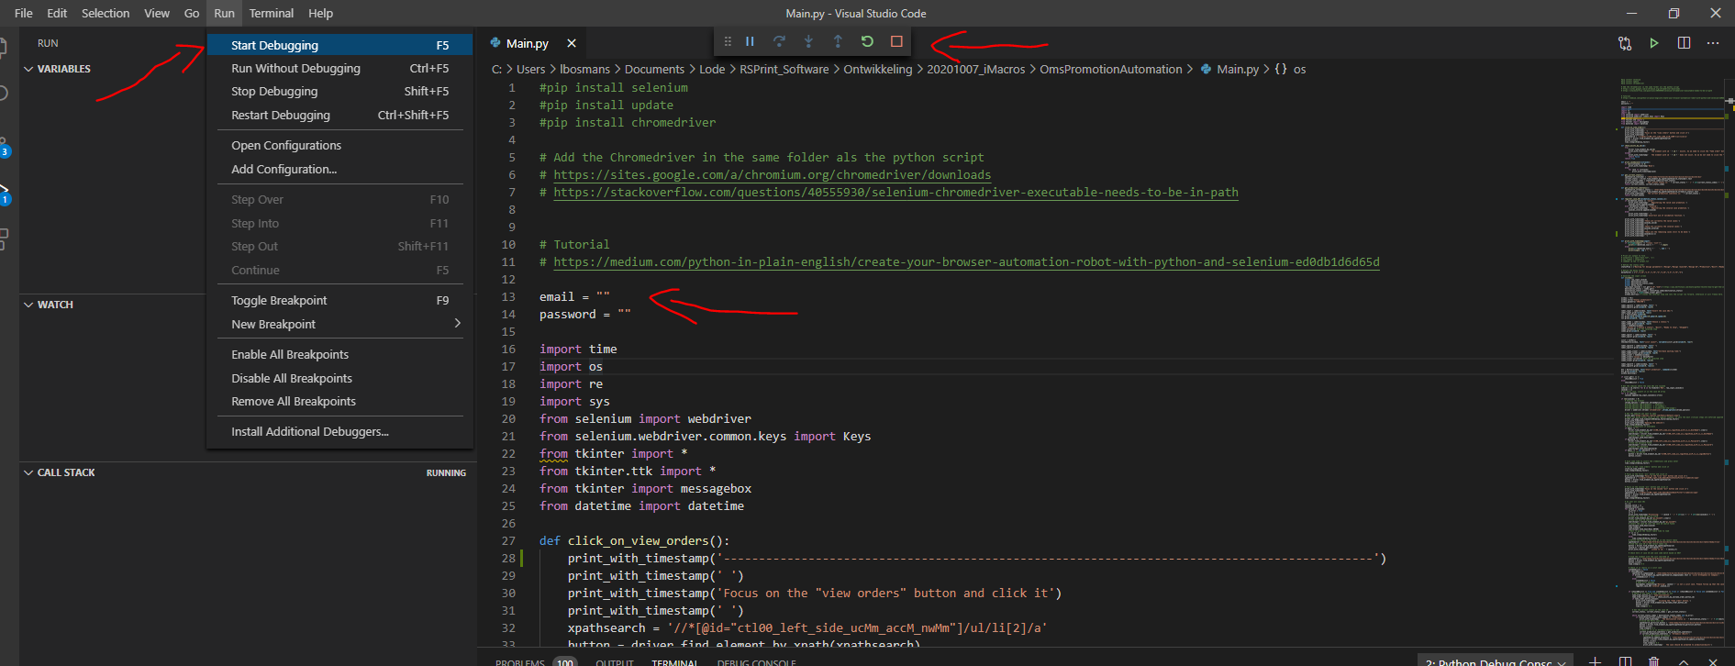

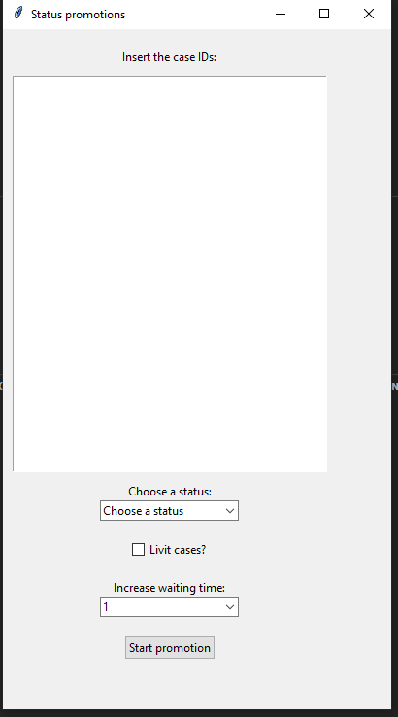The tool will open an interface where the necessary information needs to be inserted:

* Insert the case IDs
  + The case IDs need to be inserted in the text field.
  + The tool will filter the case ID automatically. You do not need to worry about additional text that is copied into the field. The tool will search for ‘RSX’, where the X resembles a number. Based on the found indices, it can extract the case IDs. Additional text is ignored.
* Choose a status
  + Select the destination status.
  + The tool will sequentially go through all statuses until the destination status has been reached.
  + If the destination status has been reached or even further than the destination status, the tool will do nothing. It will proceed to the next case.
* Livit case?
  + Do some extra check for a specific customer. Can be ignored.
* Increase waiting time
  + This is a factor applied to the waiting time of the browser. If the OMS is slower, you can consider increasing the waiting time, in order for the browser not to get a timeout error.

Useful information will be displayed in the terminal on the bottom:

* Current case that is being processed and substeps.
* List of cases:
  + Valid cases = promoted to the destination status.
  + Invalid cases = could not be promoted to the destination status.
  + Remaining cases = cases that still need to be done.

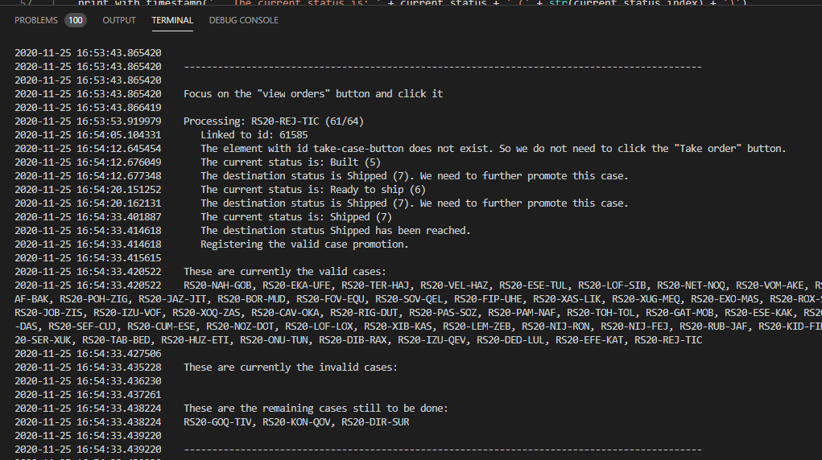

When the script is finished, it will summarize the valid and invalid cases again.

If the tool should fail, you can restart it based on the information in the terminal. Take the remaining cases and the cases that did not get promoted. Be sure check this every time. If the script is finished, it doesn’t mean all promotions are done correctly!

**Use of the script using cmd**

Insert cmd in the header and press enter. A cmd will open in this folder.

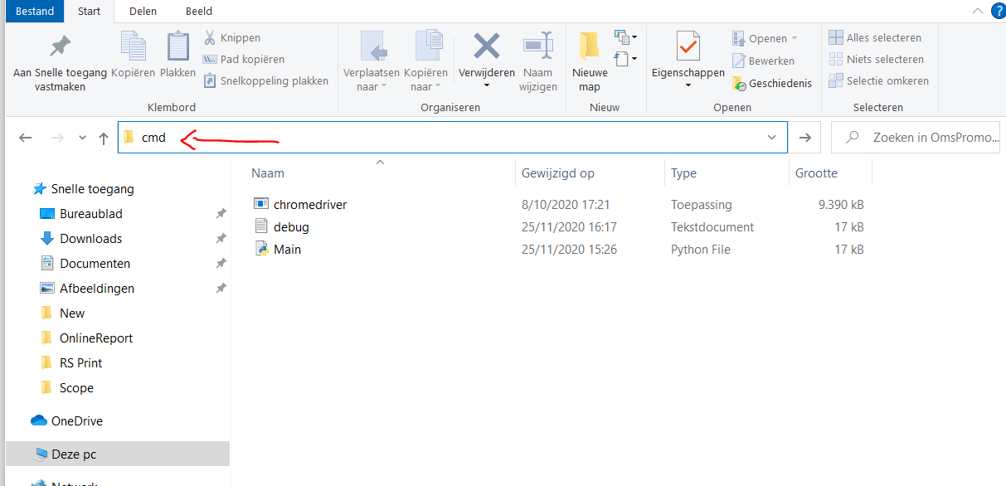

Insert main.py and press enter. The tool will start.

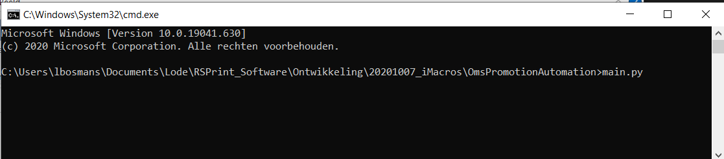

You can also just click the main.py file. But I have noticed that the tool often closes without an error message after you click the start promotion button. So it is safer to activate the tool with a cmd prompt.

**Best practices:**

* The chrome browser that is opened needs to be as large as possible. The OMS uses dynamically generated tables. If the browser is too small in dimensions, the table might not be able to visualize the required row. If the row is not visualized, the page elements that the python tool wants to grab, might not exist as the browser is too small to show it on the screen. Therefore, always maximize the browser dimensions.
* Difference in promotion time
  + Production to built
    - Requires the most time. It is advised to initiate the steps from production to built as soon as possible during the day. This way, the tool has more time to process the promotions.
  + Built to further status
    - Requires the least time.
  + Ideal day planning
    - Morning
      * Promote from production to built.
    - After shipment
      * Promote from built to shipped.
* Running to tool on multiple devices allows you to spread the workload. It does require more monitoring for it the script fails. It is advised to increase the waiting time to reduce the risk of timeout errors.
* When running to the tool without monitoring, it is also advised to increase the waiting time. This reduces the risk for timeout errors.